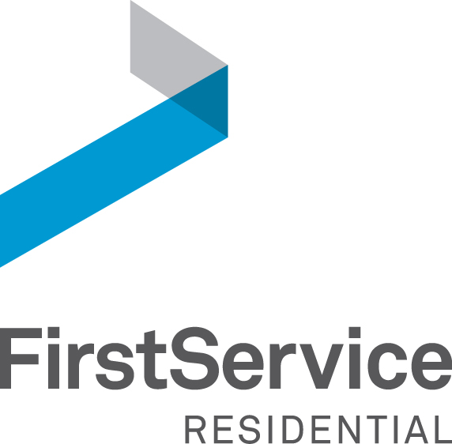

AUTOMATIC DEBIT PROGRAM APPLICATION

I authorize FirstService Residential DC Metro, LLC (formerly Armstrong Management Services, LLC), as managing agent for ________________________________________ (homeowners association), to automatically debit my [ ] checking [ ] savings account.

Application Type (please circle one): New Application or Bank Change Only

**Bank Routing # ____________________________________________________________

**Bank Account # ____________________________________________________________

Financial Institution ____________________________________________________________

City _____________________________ State ________________ Zip ________________

**Please note that with credit unions, information for automatic debit may be different than what is printed on the check or deposit ticket.

Staple voided check here

I understand that this authorization will be in effect until I notify my managing agent in writing that I no longer desire this service, allowing management reasonable time to act on my notification. I also understand that if corrections in the debit amount are necessary, it may involve an adjustment (credit or debit) to my account. I acknowledge that the transaction will occur during the first week of each month the Assessment is due. I also understand that there is a service charge per payment returned, for any reason. If two payments are returned within one year, the service will be stopped and I will be responsible for making payments on balances due.

THIS AUTHORIZATION IS NONNEGOTIABLE AND NONTRANSFERABLE.

Association Name ___________________________________________________________

Property Address (for payment to be applied) ___________________________________________

Assessment Account Number __________________________________________________

Payor’s Name & Email_________________________________________________________

Payor is (please circle one): Owner Renter Other: ______________________

Phone Number ___________________________________________________________

Signature _______________________________________ Date _____________

The Automatic Debit Form must be received before the 15th of the month to start the draft the following month. You will receive a confirmation letter notifying you when your first automatic debit will occur. You are responsible for sending payments up until such time as you are notified in writing that your first payment will be taken out of your account.

Return to: FirstService Residential DC Metro, LLC
3949 Pender Drive, Suite 205
Fairfax, VA 22030
Ph 703.385.1133
Fax 703.591.5785

If you have any questions, please email customerservice.dcmetro@fsresidential.com.

